**Sample Phishing Email:**

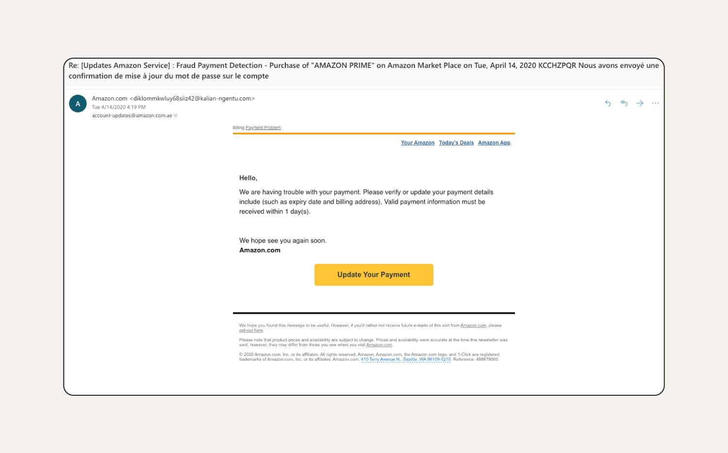



**Report of the email:**

* Sender’s address is not legitimate
* Urgency is created for the user
* Generalised message is there it is sent in bulk
* Website URL is not the real one
* The signature and email looks suspicious
* Grammar is not correctly used.
* The email is not professional.

**Header Analysis :**

I have taken a sample mail from my account and analysed its header.

Found this result:

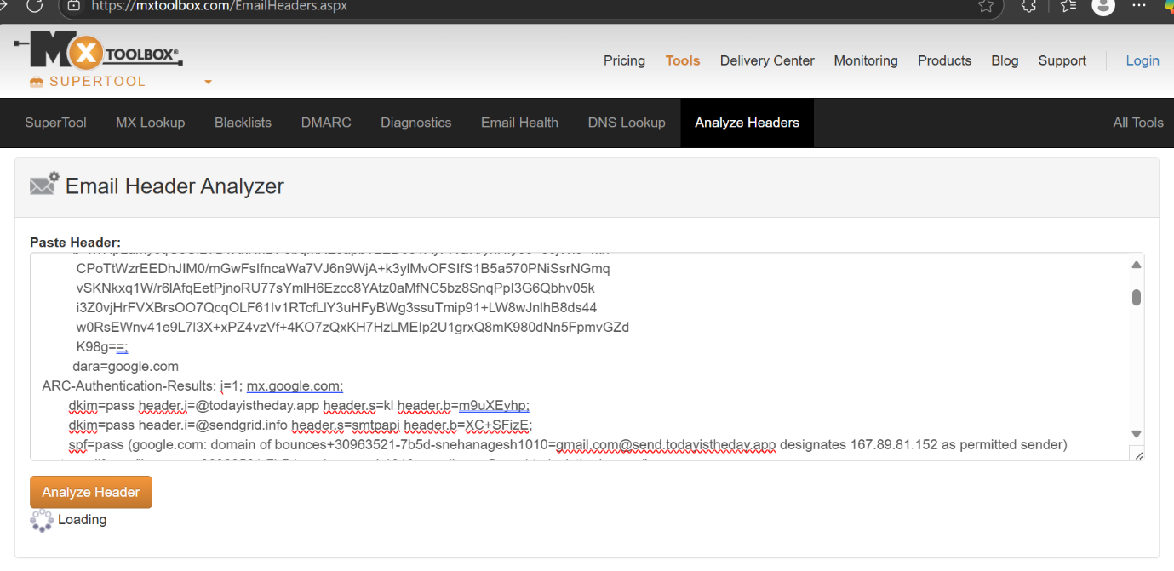

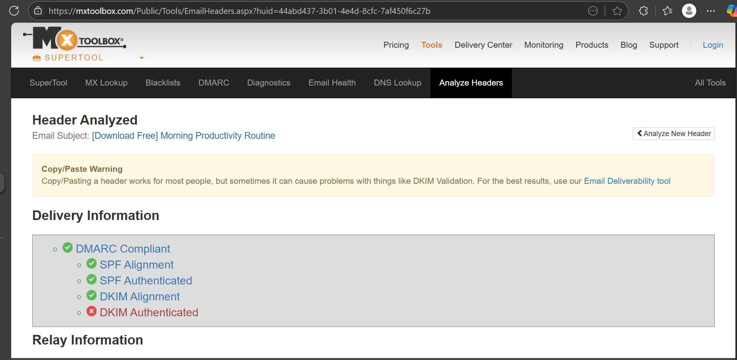

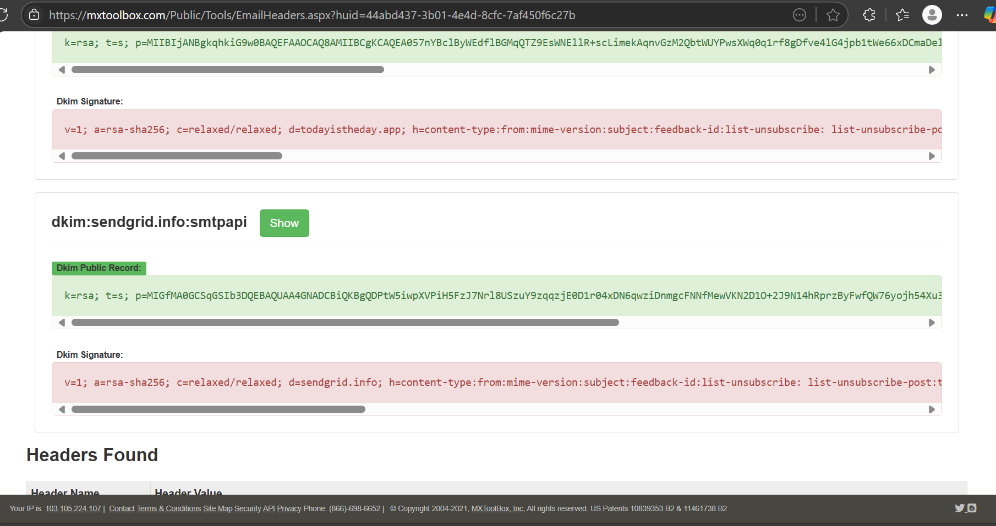

* The absence of DKIM may cause the email to be **flagged as suspicious**, **rejected**, or **spoofed**.
* And also, the mail is assumed as SPAM.